Experiment 10
Heap Sort
(MAX HEAP)
A binary heap is a heap data structure created using a binary tree. It can be seen as a binary tree with two additional constraints.
Shape property:
A binary heap is a complete binary tree; that is, all levels of the tree, except possibly the last one (deepest) are fully filled, and, if the last level of the tree is not complete, the nodes of that level are filled from left to right.
Heap property:
All nodes are either greater than or equal to or less than or equal to each of its children, according to a comparison predicate defined for the heap.
Heaps with a mathematical "greater than or equal to" (≥) comparison predicate are called max-heaps; those with a mathematical "less than or equal to" (≤) comparison predicate are called min-heaps.

Heap operations

Insert:
- Add the element to the bottom level of the heap.
- Compare the added element with its parent; if they are in the correct order, stop.
- If not, swap the element with its parent and return to the previous step.
As an example of binary heap insertion, say we have a max-heap
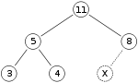
and we want to add the number 15 to the heap. We first place the 15 in the position marked by the X. However, the heap property is violated since 15 > 8, so we need to swap the 15 and the 8. So, we have the heap looking as follows after the first swap:
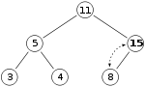
However the heap property is still violated since 15 > 11, so we need to swap again:
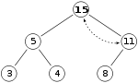

Extract:
- Replace the root of the heap with the last element on the last level.
- Compare the new root with its children; if they are in the correct order, stop.
- If not, swap the element with one of its children and return to the previous step. (Swap with its smaller child in a min-heap and its larger child in a max-heap.)So, if we have the same max-heap as before
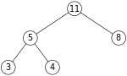
We remove the 11 and replace it with the 4.
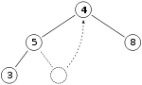
Now the heap property is violated since 8 is greater than 4. In this case, swapping the two elements, 4 and 8, is enough to restore the heap property and we need not swap elements further:
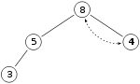
The downward-moving node is swapped with the larger of its children in a max-heap
Exercise: Write the code to sort an array using Max Heap functionality.
Your code should work for the following main program;
int main()
{
int n, i, x;
cout<<"Enter no of elements of arrayn";
cin>>n;
int a[20];
//// Take Input in a[]
build_maxheap(a,n);
heapsort(a, n);
cout<<"nnSorted Arrayn";

///Display Sorted Data
return 0;
}

Post Lab:
Find the complexity of Max Heap Sort algorithm for sorted and unsorted binary trees:

